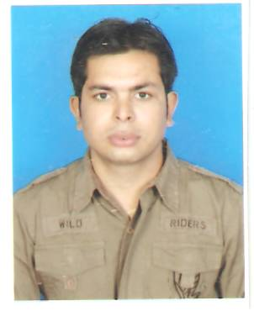 CURRICULAM VIATE
RAHUL KAPADIYA
105,ARIHANT APPARTMENT,
ALKAPURI SOC,
VAPI – 396191
MOBILE: 9898272669
EMAIL : rahulkapadiya555@gmail.com

OBJECTIVE

To use my flair for communication and knowledge of finance to carve a niche for myself in the ever competitive, dynamic and innovative world of modern banking

EDUCATIONAL QUALIFICATIONS

B.COM -2005

- Institute Roffel Arts and Commerce College.
- Department Commerce
- University South Gujarat

SKILLS SUMMARY

COMPUTER SKILLS
- M.S. Office ( Word, Power Point, Excel )
- Banking System ( Fin ware, lono )
- Accounting Package ( Tally 6.3 )

ACHIVEMENTS / PARTICIPATION
- Participated in Inter-College Volleyball Competition as Captain.
- Participated in Inter-College Cricket Competition.
- Participated in various NSS- Camp in Villages.
- Achieved 3rd Highest Account Opener in Gujarat in HDFC Bank.
- Achieved Target given by seniors every months since joining date.
- Earned incentive every month.

WORK EXPERIENCE
Worked With HBL (part of HDFC Bank) since May 2005 – Dec 2005 as a sales executive
Promoted to Team leader in HDFC Bank from Dec – 2005 To Jun-2010

currently working with kotak mahindra bank as Asst.Manager since Aug-2010

JOB PROFILE

Selling products such as CASA, DEMAT, ONLINE TRADING, MUTUAL FUNDS, INSURANCE. Team handling, Motivating Team, Area campaigning. Training Fresh Sales Executive to Deal with present Scenario

HOBBIES

- Listening to music
- Playing various sports such as Cricket, Volleyball.

INTROSPECTION

- Confident, Positive, Good Communication, Good listener, Dedicated, Attitude to Work in a Team and lead Team from the front. To bring new and innovative ideas to deal with market.

PERSONAL INFORMATION

FATHER’S NAME : MR NAGINDAS KAPADIYA

PERMANENT ADDRESS : 105,ARIHANT APPARTMENT ALKAPURI SOCIETY,
VAPI – 396191

MOBILE : 9898272669, 8155990080.

E- MAIL : rahulkapadiya555@gmail.com

DATE OF BIRTH : 02-12-1982

LANGUAGES KNOWN : ENGLISH, HINDI AND
GUJARATI

